**© 2015 – Foxes Team**

<http://process.ws>

**Abstract**

This document will introduce about Issue Management process describes how the Foxes Team will identify, analyze and manage it in Capstone Projects.

**Issue Management Process**

**Foxes Project**

**Table of Contents**

1. Introduction 2

1.1. Purpose 2

1.2. Scope 2

2. Issue Management 2

2.1. Objective 2

2.2. Process 3

3. Process Roles and Responsibilities 4

4. Process Description 4

4.1. Register the Issue 4

4.2. Analysis and Evaluate impact 4

4.3. Plan for Resolve action 5

4.4. Implement & Checking 5

5. Qualitative Issues 6

5.1. Priority 6

5.2. Impact 6

5.3. Issue Status 6

Revision 8

# Introduction

## Purpose

* Issue management is process identification, evaluation, response, control and reporting issues. Issues management plan describes how the team Foxes will identify, analyze and manage it.
* Issues management plan created by the project manager and is controlled and updated through the phases of the project.

## Scope

Scope of issue tracking process is to help Development Team can track issues occurs in Flex Team easily, describes detail the steps and methods to reduce problem occurs in the project SPM.

# Issue Management

## Objective

Project management together with the development team to identify, analyze and manage the problem occurred during the project. The issue should be resolved soon in order to minimize costs and time to the project.

## Process

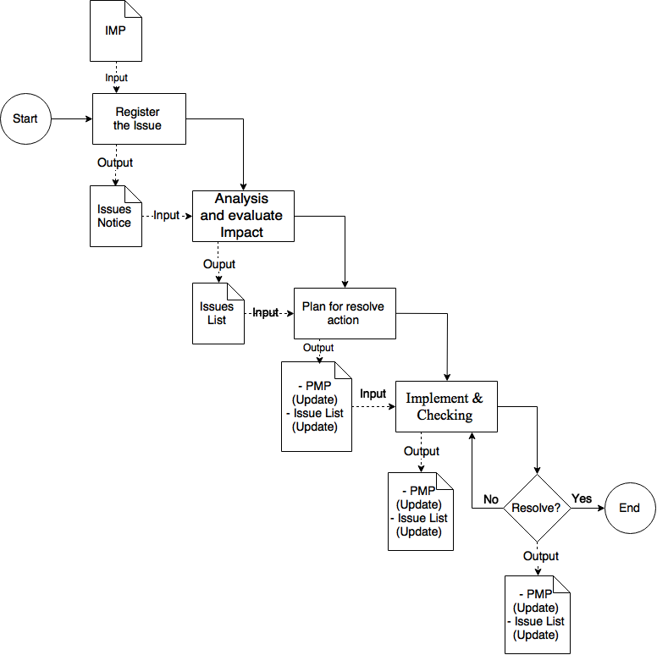

Figure – Issue Management Process

Document in this sub-process:

* PMP: Project Management Plan.
* IMP: Issue Management Process

# Process Roles and Responsibilities

|  |  |
| --- | --- |
| Roles | Responsibility |
| Project Manager | Responsible for monitor all the issue maybe happen in the project and report. |
| Team Member | Responsible for resolve the issue. Besides, support monitor and management it. |

Table 1 – Roles and Responsibilities

# Process Description

## Register the Issue

|  |  |
| --- | --- |
| **Required Input** | 1. Issue Management Process |
| **Expected Output** | 1. Issues Notice |
| **Participants** | 1. Project Manager |
| 1. Issues Manager will notice issue is happening and celebrate meeting. 2. If issues derived from risk, Issues Manager will update issues in issues log and implement stage “Implement & Checking”. 3. Issue maybe appear when start project and it will update in Issue List. | |

Table 2 – Register the Issue

## Analysis and Evaluate impact

|  |  |
| --- | --- |
| **Required Input** | 1. Issues Notice |
| **Expected Output** | 1. Issue List |
| **Participants** | 1. Project Manager 2. Team Member |
| 1. In meeting, all member analye priority, impact and make the solution for resolving issues. | |

Table 3 – Analysis and Evaluate impact

## Plan for Resolve action

|  |  |
| --- | --- |
| **Required Input** | 1. Issue List |
| **Expected Output** | 1. Project Management Plan (Update – Revision #) 2. Issue List (Update - Revision #) |
| **Participants** | 1. Project Manager 2. Team Member |
| 1. Project Manager will update schedule base on analyze of issues in meeting and assign member (Resolver) to resolving issues. Project Manager will update issues with status open | |

Table 5 – Plan for Resolve action

## Implement & Checking

|  |  |
| --- | --- |
| **Required Input** | 1. Issue List (Update - Revision #) |
| **Expected Output** | 1. Project Management Plan (Update – Revision #) 2. Issue List (Update - Revision #) |
| **Participants** | 1. Project Manager 2. Team Member |
| 1. Issues Owner will resolve issues based on plan of issues manager. 2. Verifier will implement test this issues to ensure issues has resolved.   If Checking result is Yes, this issue will be resolved; else we must back to Implement step to re-execute. Project Manager will update status of Issues in Issues list is “Resolved”. | |

Table 6 – Implement & Checking

# Qualitative Issues

Qualitative Issues including Priority, Impact & Issue Status.

## Priority

|  |  |  |
| --- | --- | --- |
| No. | Level | Description |
| 1 | Low | Low priority. |
| 2 | Medium | Medium priority**.** |
| 3 | High | High priority**.** |

Table 7 – Description Priority

## Impact

|  |  |  |
| --- | --- | --- |
| No. | Qualitative | Description |
| 1 | Low | Impact on the project at a low level. |
| 2 | Medium | Impact on the project at a medium level. |
| 3 | High | Impact on the project at a low level. |

Table 8 – Description Impact

## Issue Status

|  |  |  |
| --- | --- | --- |
| No. | Status | Description |
| 1 | Pending | Issue in the period pending |
| 2 | In Progress | Issue is resolving |
| 3 | In Review | Issue is reviewing |
| 4 | Rejected | The issue needn’t resolve |
| 5 | Resolved | The issue was completely resolved |
| 6 | Not Resolved | Issues wasn't resolved. |

Table 9 – Issue Status

# Revision

|  |  |  |  |
| --- | --- | --- | --- |
| # | Date | Editor | Description |
| 4 | Sep 6th, 2015 | Tỷ Trần | * Updating with the new template. * Adding some of table description. |
| 3 | Aug 21th, 2015 | Chi Tô | * Update and complete document. |
| 2 | Aug 19th, 2015 | Chi Tô | * Update document. |
| 1 | Aug 18th, 2015 | Chi Tô | * Create document. |